4 неделя
Correlation and regression analysis
The purpose of the lecture: to study the basics of correlation and regression analysis and their implementation in solving problems
Lecture Plan:
1. Basics of correlation and regression analysis.
2. Linear and nonlinear regressions.
3. Implementation of regression analysis.
Implementation of correlation analysis.
1. Basics of correlation and regression analysis.
2. Correlation is the statistical relationship of two or more random variables (or quantities that can be considered as such with some permissible degree of accuracy).
3. Correlation analysis is a method of processing statistical data by which the tightness of the relationship between two or more variables is measured.
Limitations of correlation analysis:
1) Application is possible if there are enough observations to study. In practice, it is considered that the number of observations should be at least 5 6 times the number of factors.
2) It is necessary that the set of values ​ ​ of all factor and effective features obey the multivariate normal distribution.
3) The initial set of values must be qualitatively uniform.
4) The fact of correlation itself does not give reason to argue that one of the variables precedes or is the cause of the changes, or that the variables are generally causally related, and not the action of the third factor is observed.
5) Regression is the dependence of the average value of any random variable on some other variable or several variables.
6) Regression analysis is a section of mathematical statistics that combines practical methods for studying regression dependence between values ​ ​ according to statistical observations.
7) The task of correlation analysis is to determine the tightness and direction of communication between the studied values.
8) During regression analysis, an analytical expression of the relationship of a dependent random variable Y (effective feature) with independent random variables Kh1, Kh2,... Xm (factors) is determined.
9) In practice, we are talking about, analyzing the set of points on the graph (i.e., the set of statistics), finding a line that, if possible, accurately reflects the pattern contained in this set, the tendency is the regression line.
10) The regression equation is a form of the association of the effective characteristic Y with the factors Kh1, Kh2,... Xm. Depending on the type of equation selected, linear and nonlinear (quadratic, exponential, logarithmic, etc.) regression are distinguished.
11) Depending on the number of interrelated features, paired and multiple regression are distinguished.
12) Paired - the relationship between two features (effective and factor) is investigated.
13) Multiple (multifactorial) - between three features (effective and several factor).
Sequence of regression analysis steps
1) Formulation of the task. At this stage, preliminary hypotheses about the dependence of the studied phenomena are formed.
2) Definition of dependent and independent (explaining) variables.
3) Statistical data collection. Data should be collected for each of the variables included in the regression model.
4) The formulation of the hypothesis about the form of communication (paired or multiple, linear or non-linear).
5) Definition of regression function (consists in calculation of numerical values of parameters of regression equation)
6) Estimation of regression analysis accuracy.
7) Interpretation of the results obtained. The obtained regression analysis results are compared with preliminary hypotheses. The correctness and likelihood of the results are assessed.
8) Predicting unknown values of a dependent variable.
2. Linear and nonlinear regressions.

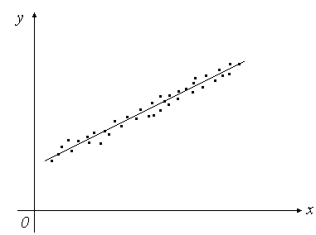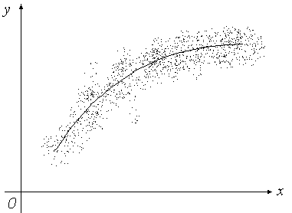

Figure 1 - linear regression Figure 2 - linear regression

In process modeling, in many cases, the relationship between input (x) and output (y) parameters can be approximated by a linear polynomial (constraint)
To obtain the type of mathematical model, you need to define the coefficients of the regression equation b0 and b1. To do this, use the method.

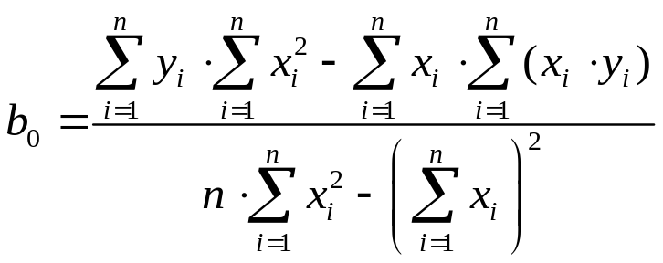
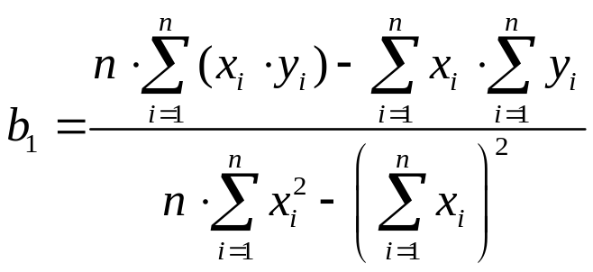

Nonlinear regression

1. Implementation of regression analysis.
Multiple linear regression equation
where are theoretical values of the effective feature obtained by substituting the corresponding values of the factor features into the regression equation;
- values of factor characteristics;
- parameters of equation (regression coefficients).

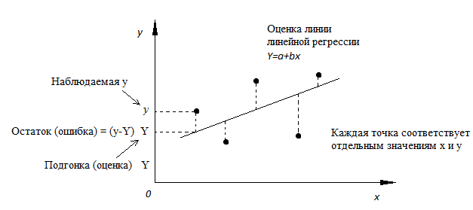
Figure - Line of linear regression with the shown residues (vertical dashed lines) for each point.

Least squares method
The parameters of the regression equation can be determined using the least squares method used in the Regression Data Analysis Package (MS Excel):
there are model parameters, at which the sum of squares of deviations of empirical (actual) values ​ ​ of the effective characteristic from theoretical values ​ ​ obtained from the chosen regression equation is minimized, i.e.
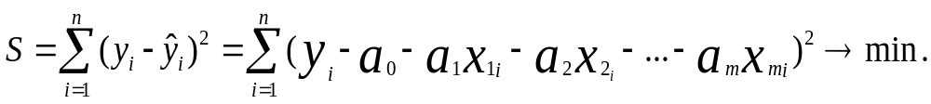
Considering S as a function of parameters and conducting mathematical transformations (differentiation), we obtain a system of normal equations with m unknowns (by the number of parameters).
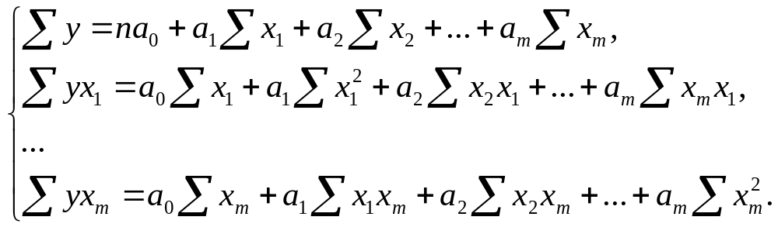

Here n is the number of observations, m is the number of factors in the regression equation.
The solution of the system allows you to obtain values ​ ​ of regression parameters.
In order to determine the extent of the stochastic relationship between the effective characteristic Y and the factors X, the following variances must be known:
general variance of the effective characteristic Y, showing the influence of both main and residual factors:

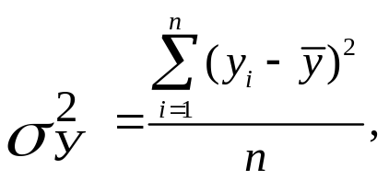
where is the average value of the effective characteristic Y.
• factor variance of the effective characteristic Y, showing the influence of only the main factors

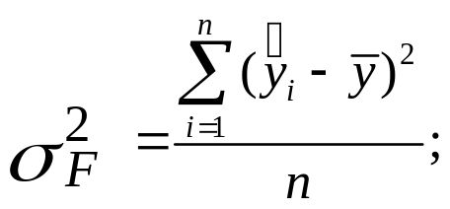
• residual variance of the effective characteristic Y, showing the influence of only residual factors
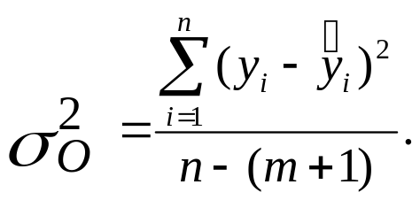
In case of correlation of the effective characteristic and factors, the ratio is performed
prt this 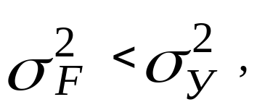
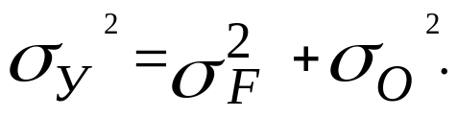

Determining the Determination Factor 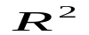

To analyze the overall quality of the linear multifactor regression equation, a multiple determination coefficient, also called the square of the multiple correlation coefficient, is used.

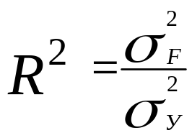
and determines the proportion of variation of the effective feature due to the change in factor features included in the multifactorial regression model.
The R-square value, also called a measure of certainty, characterizes the quality of the resulting regression line. This quality is expressed by the degree of correspondence between the original data and the regression model (calculation data). The certainty measure is always within the range [0; 1].
In most cases, the value of the R-square is between these values, called extreme, i.e. between zero and one.
If the value of the R-square is close to one, this means that the constructed model explains almost all the variability of the corresponding variables. Conversely, an R-square value close to zero means poor quality of the constructed model.
Multiple R - the coefficient of multiple correlation R - expresses the degree of dependence of independent variables (X) and dependent variable (Y).
Multiple R is equal to the square root of the determination coefficient, this value takes values ​ ​ in the range from zero to one.
In simple linear regression analysis, the plural R is equal to the Pearson correlation coefficient.
Fisher Test Definition F
Since in most cases the regression equation has to be built on the basis of sample data, the question arises about the adequacy of the constructed equation with the data of the general population. To do this, the statistical significance of the determination coefficient is checked based on the Fischer F-test:
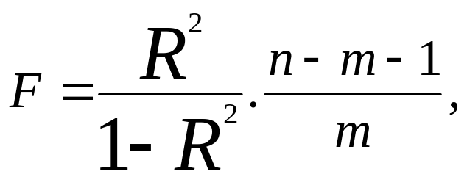
where n is the number of observations m is the number of factors in the regression equation.
If in the regression equation the free term is 0, then the numerator n-m-1 should be increased by 1, i.e. it will be equal to n-m.
Determining an Approximation Error

It is possible that some of the calculated regression coefficients do not have the necessary degree of significance, i.e. the values of these coefficients will be less than their standard error. In this case, such coefficients should be excluded from the regression equation.
Therefore, checking the adequacy of the constructed regression equation along with checking the significance of the determination coefficient also includes checking the significance of each regression coefficient.
Definition of t-criterion
To assess the adequacy of the regression equation, an average approximation error measure is often also used.

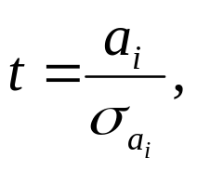
where is the standard error value for the regression coefficient
In mathematical statistics, it is proved that if the hypothesis is fulfilled, then the value t has a Student distribution with k = n-m-1 number of degrees
freedoms, i.e. 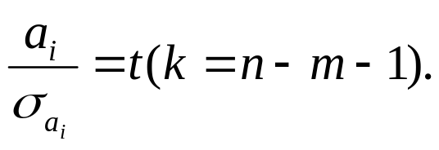
hypothesis 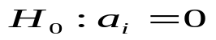о insignificance of regression coefficient is rejected if
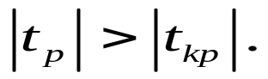

Defining Trust Interval Boundaries
Knowing the value, you can find the limits of confidence intervals for regression coefficients

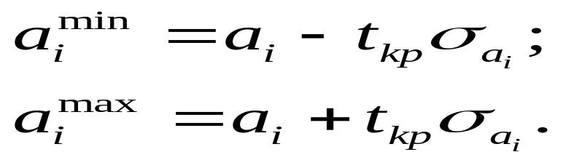
Результаты регрессионного анализполученные с помощью MS Excel
